Spectral coherence: USDCHF and USDCAD
Method 21 / daily log returns / Welch magnitude-squared coherence / Alpari D1 full available history

Study setup
Logical pair: USDCHF , USDCAD
Broker symbols: USDCHF_i , USDCAD_i
Snapshot: 2026-11-03_majors_alpari_D1
Timeframe: D1
Matched return window: 1999-01-05 to 2026-11-02 (UTC bar dates)
Matched return count n: 7188
Dropped unfinished last bar dated 2026-11-03 UTC after a tick-volume check against the prior complete day.
Welch: fs=1.0, nperseg=256, noverlap=128, window=hann, detrend=constant
Headline: gamma^2 nearest f=1/5; also 1/21 and 1/63
Complete matched rows (Excel): USDCHF-USDCAD_Spectral_D1.xlsx
Complete matched rows (HTML table): USDCHF-USDCAD_Spectral_D1_data.html

Method carried forward
Magnitude-squared spectral coherence gamma^2(f) measures shared linear power between matched daily log returns of close, ln(close_t / close_t-1), at each frequency f (cycles per day). Quotes are not inverted. Welch settings are frozen: fs=1, nperseg=256, noverlap=128, window=hann, detrend=constant. Headline is gamma^2 at the frequency bin nearest f=1/5 (five-day cycle from the formula sheet). Also reported: gamma^2 nearest f=1/21 and f=1/63, mean gamma^2 over the frequency grid, and phase of the cross-spectrum at the 1/5 bin. Coherence is unsigned (0 to 1); phase carries timing. Same-sample Pearson r is a side check only. This is not causation and not a trading signal.

Results (headline)
gamma^2 near 1/5: 0.115453
bin f (1/5): 0.199219
phase at 1/5 (rad): 0.624490
gamma^2 near 1/21: 0.051186
gamma^2 near 1/63: 0.161992
mean gamma^2: 0.120846
Pearson r: 0.304665

Target-frequency summary
period | target_f | f_bin | gamma2 | phase_rad
5 | 0.2 | 0.19921875 | 0.1154531 | 0.62448997
21 | 0.04761905 | 0.046875 | 0.05118614 | 0.02860257
63 | 0.01587302 | 0.015625 | 0.16199157 | 0.18276834

Conclusion
Headline gamma^2 near f=1/5 for USDCHF and USDCAD: 0.1155 (bin f=0.199219, phase=0.6245 rad). At ~1/21: 0.0512; at ~1/63: 0.1620. Mean gamma^2 = 0.1208. Pearson r = 0.3047. This is frequency-domain linkage, not a trading signal.

Charts
Daily closes

Daily log returns

Spectral coherence gamma^2(f)
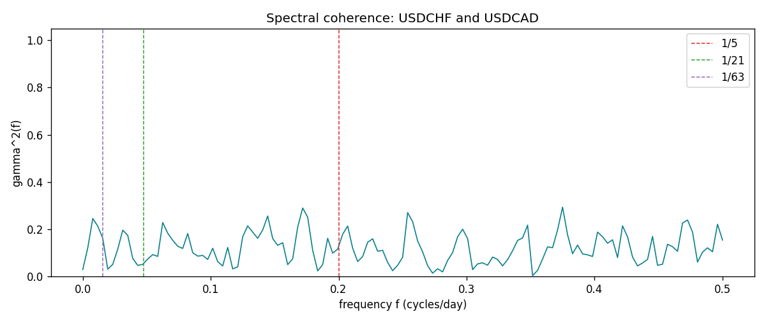

Data report
Matched rows and the coherence sheet are in the sibling Excel workbook named USDCHF-USDCAD_Spectral_D1.xlsx. Embedding all rows as a Word table is impractical; this file holds column summaries and the first and last 15 matched rows.
Columns: time, USDCHF_open, USDCAD_open, USDCHF_high, USDCAD_high, USDCHF_low, USDCAD_low, USDCHF_close, USDCAD_close, USDCHF_tick_volume, USDCAD_tick_volume, USDCHF_spread, USDCAD_spread, USDCHF_real_volume, USDCAD_real_volume, USDCHF_log_return, USDCAD_log_return
Column summaries (matched calculation rows)
column | count | mean | std | min | 25% | 50% | 75% | max
USDCHF_open | 7188 | 1.0975966 | 0.25229688 | 0.72022 | 0.9205375 | 0.989955 | 1.2378 | 1.8219
USDCAD_open | 7188 | 1.2667824 | 0.16892678 | 0.9168 | 1.1183975 | 1.298465 | 1.3720475 | 1.6183
USDCHF_high | 7188 | 1.1028875 | 0.2540352 | 0.73305 | 0.924845 | 0.993545 | 1.242375 | 1.8313
USDCAD_high | 7188 | 1.2716804 | 0.16888565 | 0.9336 | 1.12285 | 1.30387 | 1.37646 | 1.619
USDCHF_low | 7188 | 1.0924772 | 0.25071604 | 0.08565 | 0.91725 | 0.9863 | 1.23155 | 1.8121
USDCAD_low | 7188 | 1.2622243 | 0.16896256 | 0.9056 | 1.114065 | 1.293535 | 1.3677775 | 1.6102
USDCHF_close | 7188 | 1.0975873 | 0.25219296 | 0.72025 | 0.920805 | 0.98995 | 1.2379 | 1.8217
USDCAD_close | 7188 | 1.2667976 | 0.16890032 | 0.916 | 1.118075 | 1.29844 | 1.372365 | 1.6137
USDCHF_tick_volume | 7188 | 74305.244 | 113479.97 | 1 | 12787.25 | 40220 | 70419.75 | 858589
USDCAD_tick_volume | 7188 | 81017.898 | 147302.44 | 1 | 5560 | 40941.5 | 71627 | 1410818
USDCHF_spread | 7188 | 26.050501 | 24.7086 | 0 | 5 | 16 | 50 | 100
USDCAD_spread | 7188 | 23.4399 | 18.261108 | 0 | 9 | 17 | 40 | 60
USDCHF_real_volume | 7188 | 2.3284369e+10 | 8.9116261e+10 | 0 | 0 | 0 | 0 | 1.9331921e+12
USDCAD_real_volume | 7188 | 1.8376704e+10 | 9.6688094e+10 | 0 | 0 | 0 | 0 | 2.5751613e+12
USDCHF_log_return | 7188 | -7.133e-05 | 0.00659527 | -0.19545699 | -0.0033544 | 8.077e-05 | 0.00332477 | 0.09051364
USDCAD_log_return | 7188 | -1.556e-05 | 0.00514382 | -0.03859748 | -0.00283746 | 4.44e-05 | 0.00272629 | 0.03436319
First 15 matched rows (selected columns)
time | USDCHF_log_return | USDCAD_log_return
1999-01-05 | 0.0039424743 | -0.010131666
1999-01-06 | 0.013605652 | -0.0003306769
1999-01-07 | -0.0093883841 | 0.0015202092
1999-01-08 | 0.011040268 | -0.0020495197
1999-01-11 | 0.0052963193 | -0.0035137769
1999-01-12 | -0.0098275602 | 0.0066194721
1999-01-13 | -0.018259701 | 0.0045420214
1999-01-14 | -0.0024256692 | 0.0069376546
1999-01-15 | 0.01794228 | -0.0056905671
1999-01-18 | -0.0031856384 | 0.00098344542
1999-01-19 | -7.2518946e-05 | 0.002748513
1999-01-20 | 0.0072259871 | -0.0059646885
1999-01-21 | -0.0038232689 | -0.0042823796
1999-01-22 | -0.0001445609 | 0.0025057712
1999-01-25 | 0.0024546976 | 0.00085579808
Last 15 matched rows (selected columns)
time | USDCHF_log_return | USDCAD_log_return
2026-10-13 | -0.0024955621 | -0.0046395653
2026-10-14 | 0.0029388325 | 0.0015184751
2026-10-15 | -0.0097855323 | -0.0036101503
2026-10-16 | -0.0036230826 | -0.0034322068
2026-10-19 | 0.0036351779 | -0.0018835331
2026-10-20 | -0.0026281224 | -0.0037066008
2026-10-21 | -0.00040027413 | -0.00084691787
2026-10-22 | -0.0048036381 | -0.0026307268
2026-10-23 | 0.005652514 | 2.85545e-05
2026-10-26 | 0.0018407959 | 5.7106554e-05
2026-10-27 | 0.0026100526 | 0.0025379458
2026-10-28 | -0.0010142111 | -0.0038379274
2026-10-29 | -0.0048680164 | -0.00011436495
2026-10-30 | 0.00071594559 | -0.0010298736
2026-11-02 | -0.0071459744 | 0.00061519094
First 15 frequency bins
f | gamma2 | phase_rad | period_days
0 | 0.02914312 | 0 | inf
0.00390625 | 0.12090793 | -0.06443628 | 256
0.0078125 | 0.24532669 | 0.00787483 | 128
0.01171875 | 0.21343949 | 0.15125505 | 85.333333
0.015625 | 0.16199157 | 0.18276834 | 64
0.01953125 | 0.03102186 | 0.32223663 | 51.2
0.0234375 | 0.05113567 | 0.19020026 | 42.666667
0.02734375 | 0.11555048 | 0.30396219 | 36.571429
0.03125 | 0.19605113 | 0.28301222 | 32
0.03515625 | 0.17389242 | 0.23253571 | 28.444444
0.0390625 | 0.07676675 | 0.27826315 | 25.6
0.04296875 | 0.04689698 | -0.11243413 | 23.272727
0.046875 | 0.05118614 | 0.02860257 | 21.333333
0.05078125 | 0.07378845 | 0.14748541 | 19.692308
0.0546875 | 0.09247227 | 0.29601763 | 18.285714

